WEEK-07-SEARCHING ALGORITHMS-LINEAR AND BINARY

WEEK 07-01-PRACTICE SESSION CODING REG NO : 240901086

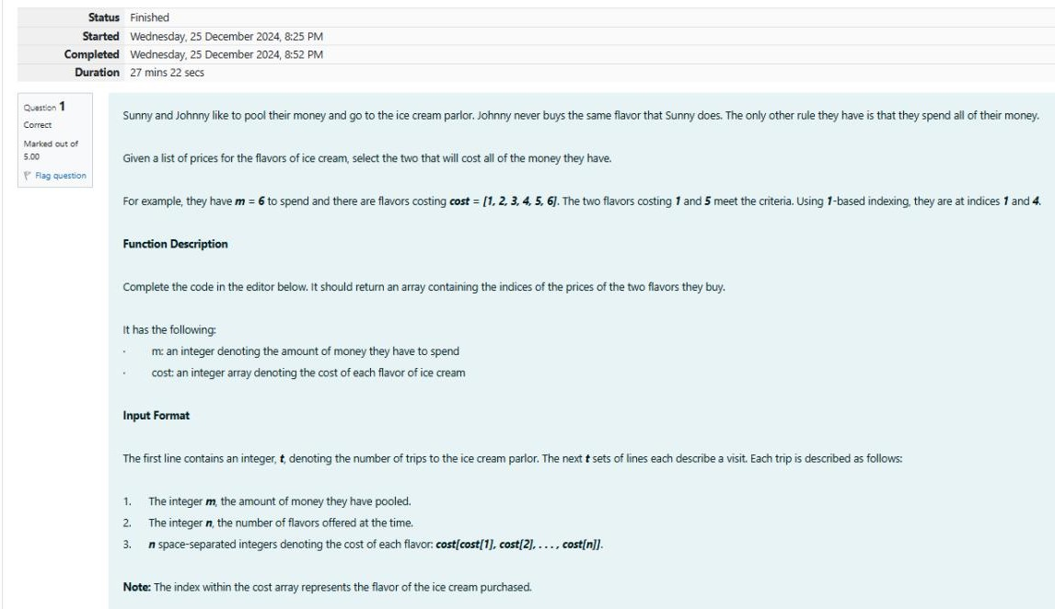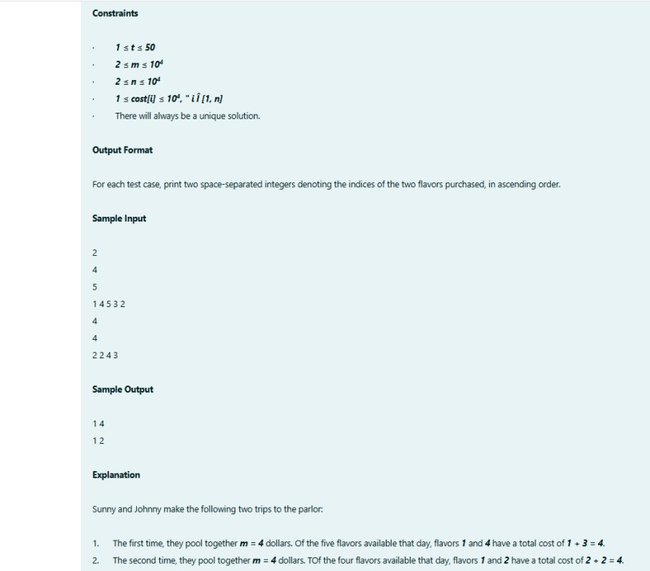NAME : RENUGADEVI S Q1)

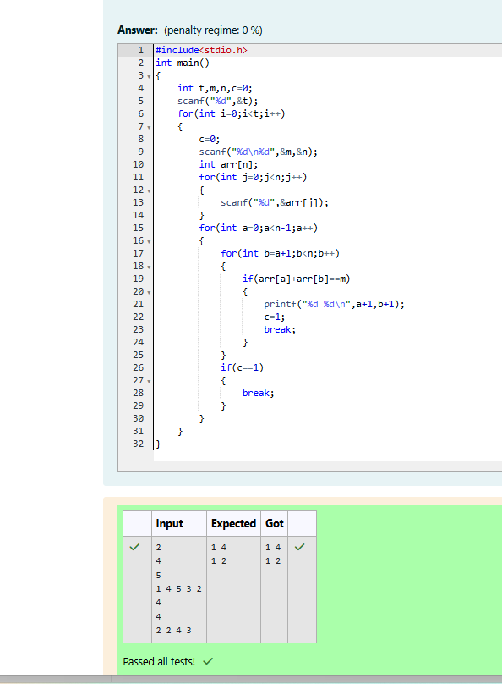

WEEK 07-01-PRACTICE SESSION CODING

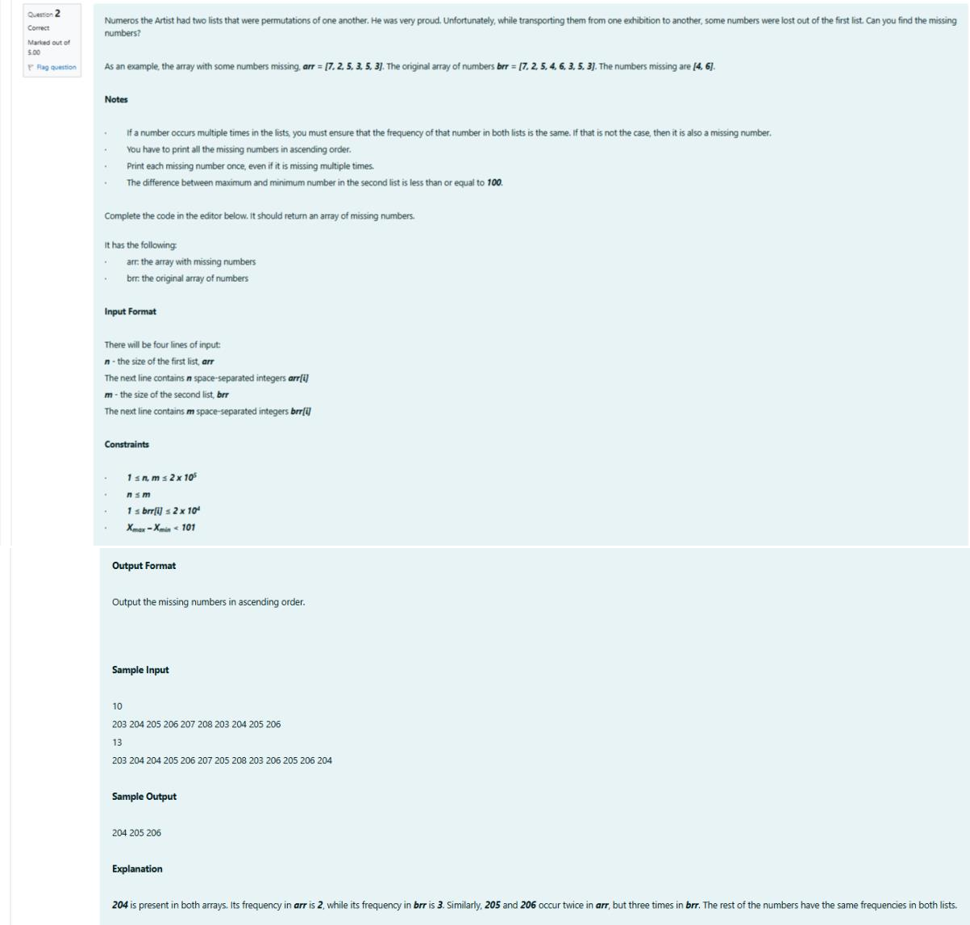REG NO : 240901086 NAME : RENUGADEVI S Q2)

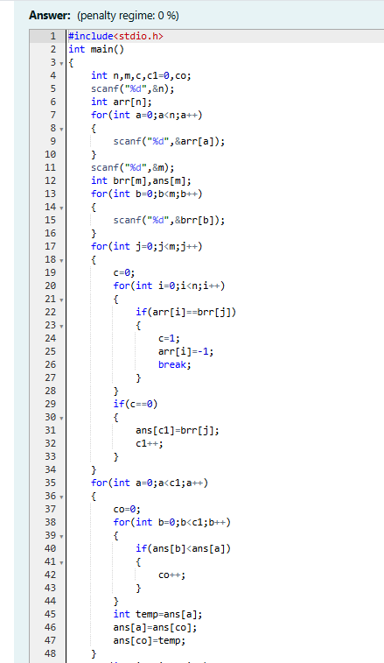

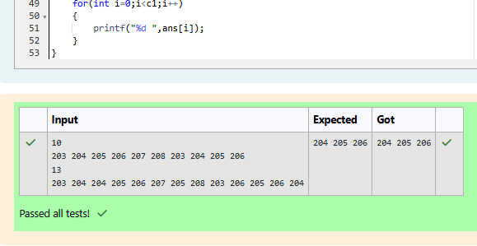

WEEK 07-01-PRACTICE SESSION CODING REG NO : 240901086

NAME : RENUGADEVI S Q3)

